Logical Backup

We can take logical backup of

1. **Full database level**
2. **Schema level**
3. **Table level**

**Command:** exp - To export data from database

Imp - To import data into database

File - To specify dump file name

Log - To specify log file name

Full - To export full database

Owner - To export Schema level

Tables - To export Table level

Query - To export subset of table data

Grants - To export all grants on the table(y/n)

Indexes- - To export all indexes on the table(y/n)

Feedback - Displays progress report of export/import

Consistent - Whether the entire export is consistent or not (Y/n)

Filesize - Limits the dump file size

Fromuser - From which user you want to import

Touser - into which user you want to import

Type exp help=y

**FULL DATABASE LEVEL EXPORT**

To export full database, you must be a DBA or have a exp_full_database privilege.

**~] $ exp system/manager file=full.dmp log=full.log full=y**

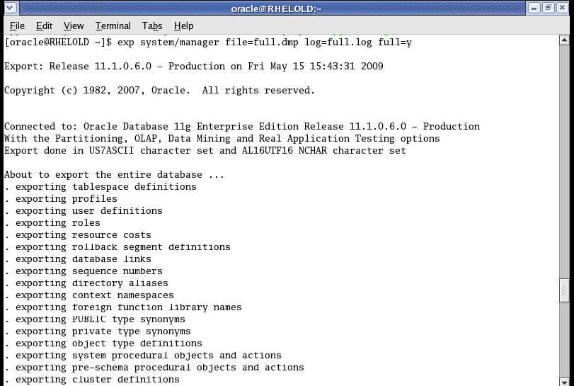

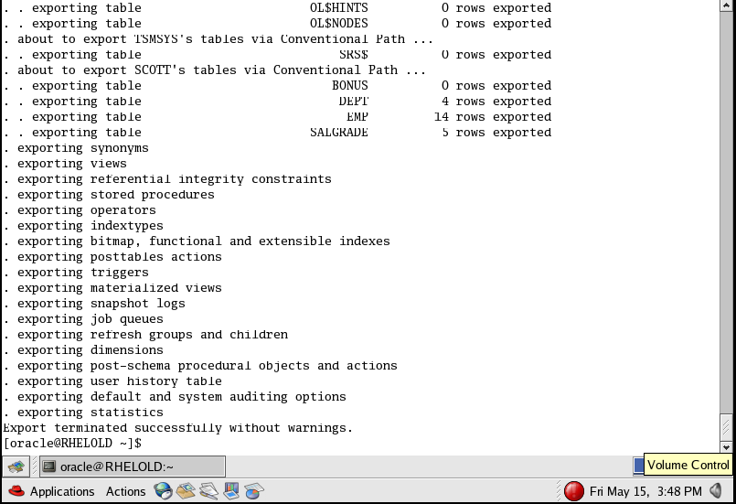

Full database level import

To import full database, you must be a DBA or have a imp_full_database privilege.

**~] $ imp system/manager file=full.dmp log=full.log full=y ignore=**y -> enter

**Ignore=y** -> parameter specifies that just ignore if object already exists.



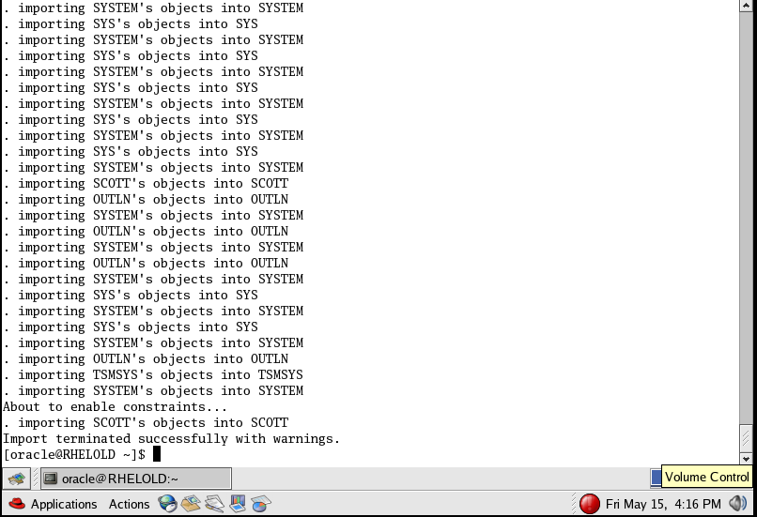

While importing, the DDL operations will be performed .

After that the DML operations will be performed.

**SCHEMA/ USER LEVEL EXPORT**

A DBA can take backup of any user’s schema or user can take a backup of his schema. By default export mode is Schema level.

By user:

**~] $ exp scott/tiger file=user.dmp log=user.log**

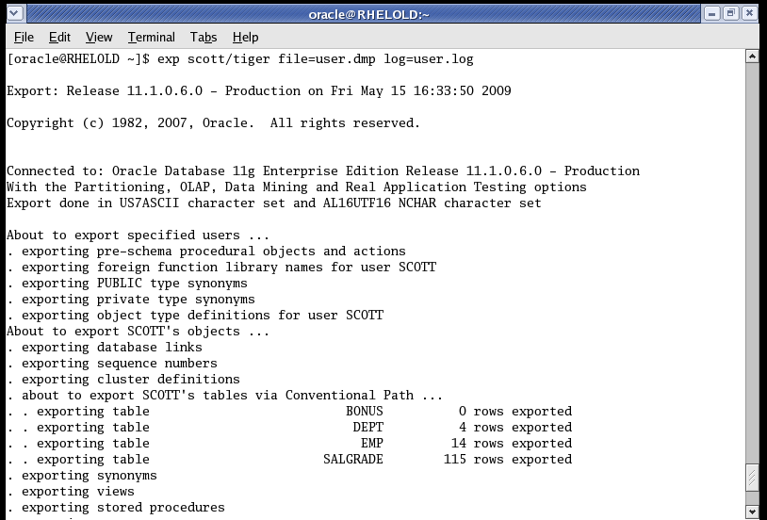

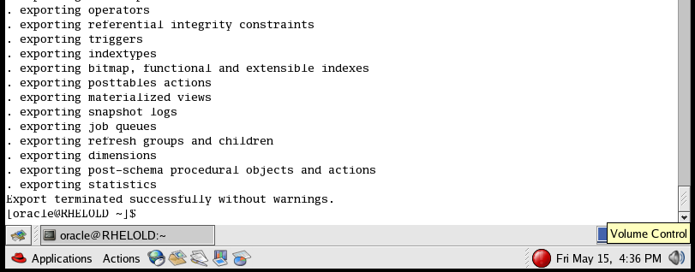

By DBA:

**~] $ exp system/manager file=user.dmp log=user.log owner=scott**

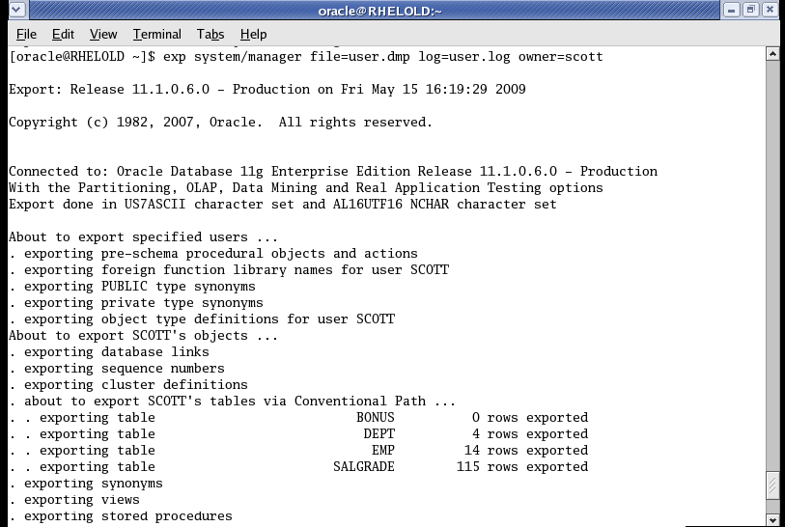

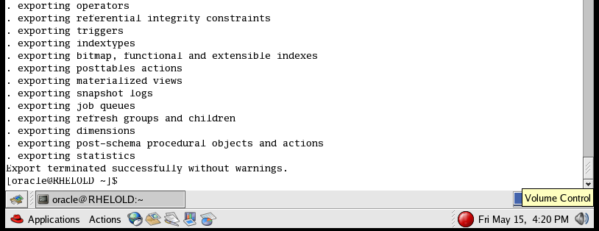

Now connect to a scott (or) any user. Drop all the rows or desired rows

By using the syntax:

**Sql>drop table tablename purge;**

Now import

SCHEMA/ USER LEVEL IMPORT

Command :

**Fromuser** -> specify from which user

**Touser** -> specify into which user

By DBA

**~] $ imp system/manager file=user.dmp log=user.log fromuser=scott**

**touser=scott**

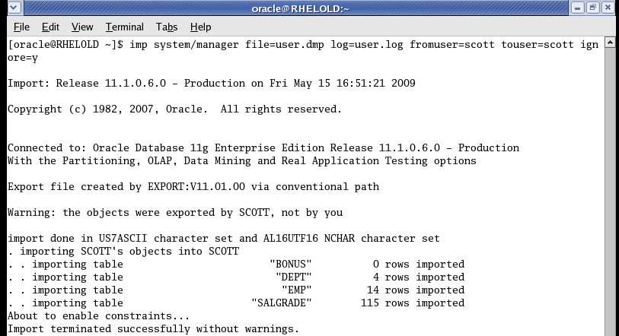

**BY USER/OWNER**

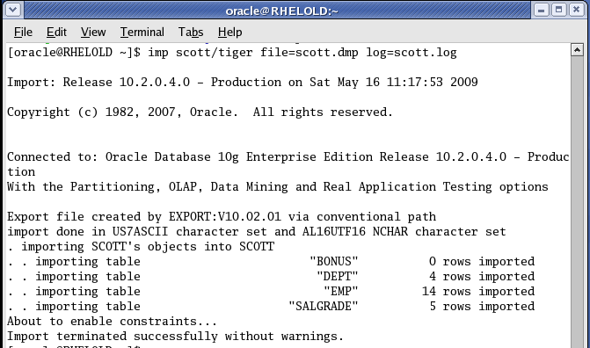

Table level export

**~] exp system/manager file=tab.dmp log=tab.log Tables=scott.emp, scott.dept**

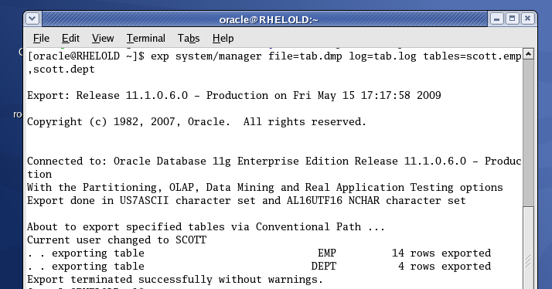

**TABLE LEVEL IMPORT**

**~] imp system/manager file=tab.dmp log=tab.log Tables=emp,dept fromuser=scott touser=scott**

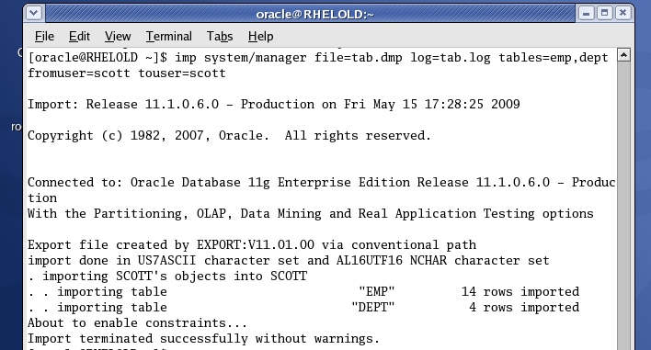

**Two export two users data**

-------------------------------------

**$exp system/system file=sch.dmp log=sch.log owner=scott,ram**

Now the dmp file contains both the schemas.

To import one users data from both the users

**$imp system/manager file=sch.dmp log=sch.log fromuser=rohit**

**MOVING TABLES FROM ONE USER TO ANOTHER USER**

**~] exp system/manager file=obj.dmp log=obj.log Tables=scott.emp,**

**scott.dept**

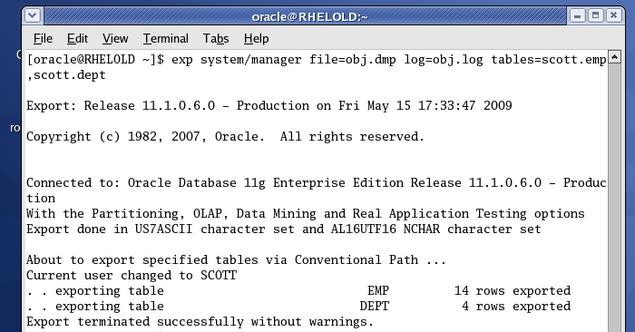

**~] imp system/manager file=obj.dmp log=obj.log tables=scott,dept**

**Fromuser =scott touser=smith**

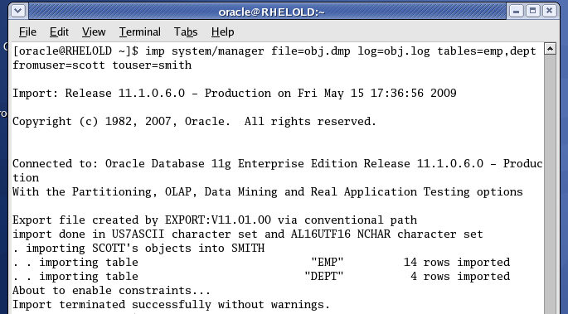

**LOGICAL BACKUPS USING DATA PUMP (10G)**

---------------------------------------------------------------------------**--**

**exp/imp database <----- expdp/impdp**

**log logfile**

**file dumpfile**

**exp expdp**

**imp impdp**

**owner schemas**

**fromuser= sourceusername touser = target username name (Normal exp and imp)**

**remap_schema=fromusername:tousername (Data Pump)**

* Data Pump technology is 15 times faster than normal exp/imp
* Data pump technology is a complete server process comes with server software.
* To use this feature we have to configre **stream_pool_size** in parameter file.
* **To store .dmp and .log file we need a directory in database level.**

**How to configure the system for DATA PUMP technology?**

----------------------------------------------------

]$vi initprd.ora

streams_pool_size=60m (standard)

:wq (save and exit)

go to database level

]$sqlplus '/as sysdba'

sql>startup

sql>create directory dpump as '/home/prd/dpump';

(dblevel) (oslevel)

sql>host

Go to OS level

]$cd /home/prd/

prd]$mkdir dpump

prd]$cd

**How to take logical backup?**

**]$expdp system/manager dumpfile=full.dmp**

**logfile=full.log directory=dpump full=y (database level directory)**

ote: here full.dmp and full.log is stored in dpump directory

**Demo:**

**----------**

sql>conn /as sysdba

conneted

chek whether streams_pool_size is configured or not

sql>show parameter streams_pool_size

not configureed

sql>shutdown immediate;

sql>exit

]$cd $ORACLE_HOME/dbs

dbs]$vi initprd.ora

add the following line

streams_pool_size=60m

:wq (save and exit)

]$sqlplus '/as sysdba'

sql>startup

check

---------

sql>show parameter streams_pool_size

60m

sql>create directory dpump as '/home/prd/dpump';

Directory created

To know the directories

sql>desc dba_directories;

sql>select DIRECTORY_NAEM,DIRECTORY_PATH FROM dba_directories;

]$ls

go to prd folder

prd]$mkdir dpump

prd]$cd

]$

Now we can take logical backup with data pump technology

]$expdp system/manager dumpfile=full.dmp logfile=full.log directory=dpump full=y

]$pwd

]$ls

full.dmp is located in /home/prd/dpump

]$cd /home/prd/dpump

dpump]$ls

full.dmp full.log

go to database level

sql>select * from all_users;

8 rows

sql>drop user amit cascade;

sql>drop user ravi cascade;

sql>commit;

go to os level

and import it

]$impdp system/manager dumpfile=full.dmp logfile=full.log directory=dpump full=y

In data pump technology ignore=y keyword is not used.

go to database level and check it.

sql>

How to take user level or schema level backup using data pump technlogies?

$expdp system/manager dumpfile=sch.dmp logfile=sch.log

schemas=amit

if u not specifying directory name it will store in default directory

go to databse level

sql>conn amit/amit;

sql>select * frm tab;

test

sql>drop table test purge;

table dropped

now import it

===========

]$impdp system/manger dumpfile=sch.dmp logfile=sch.log schemas=amit

**Schema level ExPORT**

**---------------------------**

]$expdp system/manger dupfile=test.dmp logfile=test.log

directory=dpump schemas=scott,ravi,amit

Here we are importing only one table.

$impdp system/manager dumpfile=test.dmp logfile=test.log directory=dpump tables=salgrade remap_schema=scott:scott

How to take a logical backup with multiple table level

$expdp system/manager dumpfile=t.dmp logifle=t.log directory=dpump tables=scott.emp,amit.test, ravi.demo

error:

---------

Note: Table mode exports only allow objects from one

schema

$expdp system/manager dumpfile=t.dmp logifle=t.log

directory=dpump tables=scott.emp,scott.salgrade

working fine

Here only one schema that is why it is exported.

go to database level

------------------

sql>conn scott/tiger;

sql>select * from tab;

delet some tables

import it

-------------

]$impdp system/manager dumpfile=t.dmp logfile=t.log

directory=dpump tables=emp remap_schema= scott:scott